Hard and Soft C Sorting Activity

Hard and Soft C
The letters c and g can make spelling tricky. Each of these letters has a hard sound
hard c sound (kuh): cat, cup
as well as a soft sound.
soft c sound (suh): cell, city

Usually, a c sound is hard or soft depending on the vowel that follows it.

Here's the general rule:
When c or meets a, o, or u, its sound is hard.
cap, cave, colt, comedy, curly, cuddle
When c meets e, i, or y, its sound is soft.
census, center, circle, citizen, cycle, cymbal

nb same rules for hard and soft g

Instructions

Print out on card and cut out the word cards. Ask student to sort them on to the sound cards according to whether the c has a soft or hard sound. The words are of varying difficulty and teachers can differentiate by selecting appropriate words, and can also add words of their choice.

cake | cat | cap | can | car
camera | caterpillar | caravan | carpet | cabinet
cent | cell | centre | centipede | century
celery | celebrate | cinema | city | cider
civic | cot | coffee | coat | corn
cost | coal | comb | cord | crab
cordial | combine | conduct | cut | cub
cute | cure | cup | curry | cube
cultivate | curry | curse | cuticle | cyanide

for c sounding like as /s/.  circle | 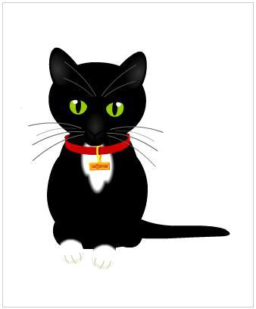  for c sounding like /k/.  cat

